BĀR

Everything you need

(Nothing you don’t)

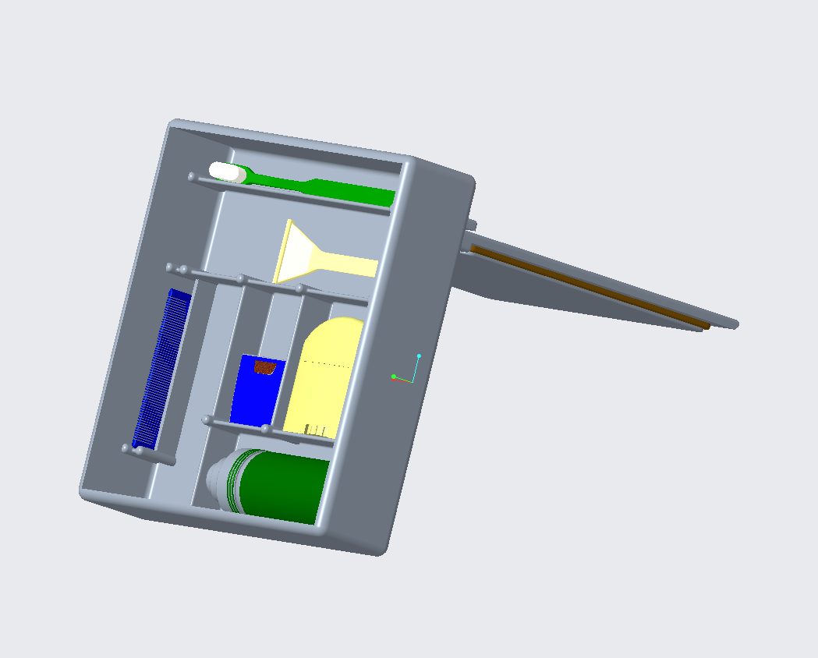

Note: Toiletries pictured are not included

Before You Begin

1. Remove your BĀR from its packaging.
2. Thoroughly wash both the container and lid. (Wash by hand or in the dishwasher)
3. Ensure your BĀR is completely dry before assembly.
4. Load up your toiletries. (Your BĀR is sized to accommodate toiletries of many sizes.)
5. Secure the watertight lid to the body.
6. Explore the world!

To Use Stand Feature:

1. Remove Lid
2. Insert longer portion of Lid (A) into retaining slot (B) on rear of container.

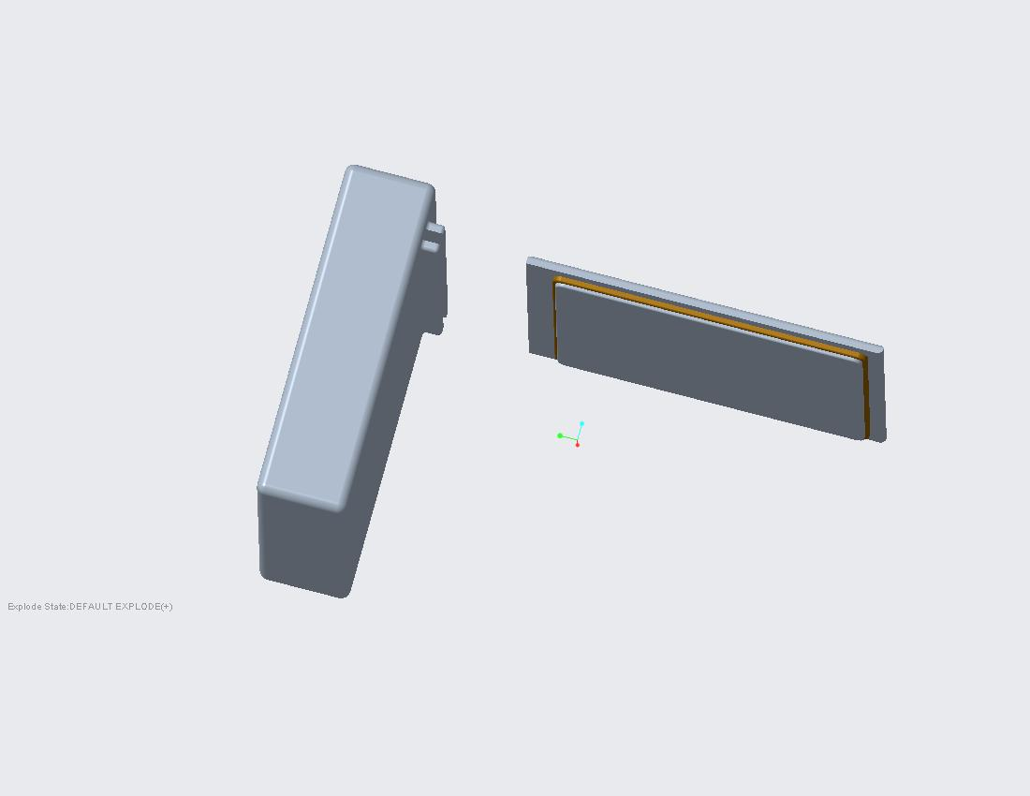

B

A

Caution:

1. Your BĀR is dishwasher safe (top rack) and food safe, but it does need to be cleaned. Periodically wash your BĀR to ensure long service life.
2. Periodically inspect your container. If damage is noticed, discontinue use.
3. Periodically inspect your gasket to ensure waterproofness. If damage is noticed, discontinue use.

Warranty

* Materials and workmanship are guaranteed for a period of one (1) year after purchase date.
* Warranty does not cover damages caused by misuse, acts of god, normal wear and tear, or bears.
* To file a warranty claim please contact us by e-mail to begin the process.
* If your warranty claim is approved, you will receive a new BĀR free of charge.

Parts List

1. Container
2. Lid
3. Silicon Gasket

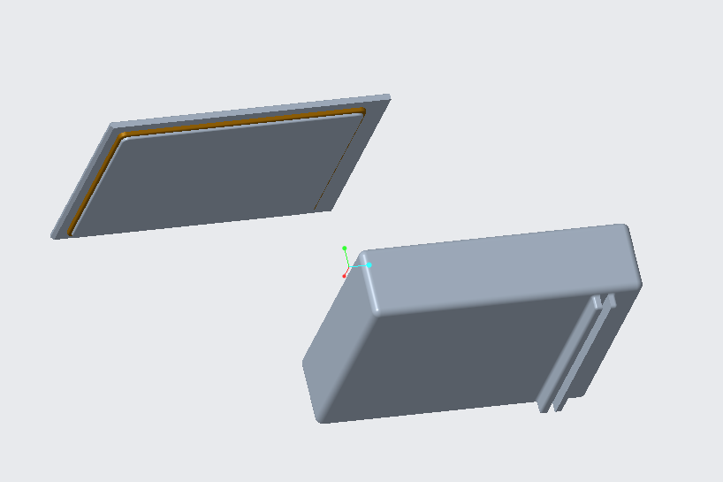

3

1

2

* The container and lid are made from polypropylene, a highly chemical resistant thermoplastic. It has a wide range of operating temperatures (0 degrees C to 130 degrees C) and is highly impact resistant. Additionally, it is food safe and can be cleaned with dish soap or baking soda and water.
* The gasket is made of silicone rubber. Silicone rubber is extremely flexible and can be cleaned with dish soap or baking soda and water. It is food safe and waterproof.

Customer Support

Scott Capehart: [acapeha1@uncc.edu](mailto:acapeha1@uncc.edu)

Joseph Conners: [jconne30@uncc.edu](mailto:jconne30@uncc.edu)

Noah Evans: [nevans20@uncc.edu](mailto:nevans20@uncc.edu)

Austin Miller: [amill263@uncc.edu](mailto:amill263@uncc.edu)